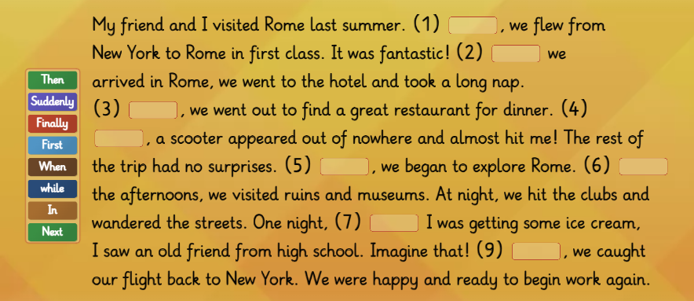
Linkers in a story- how to make a story logical and show the order of the actions.

